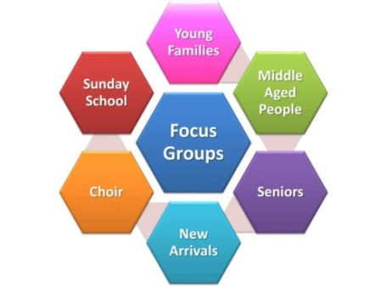 | Pakenham Pastoral Charge  Strategic Planning  Summary of Focus Group Work
General
- We need to make available to those in our church and in our wider community, our building, our community and our minister.
- We want the church to provide meaningful worship, pastoral care and outreach: we want people to be able to access the church for baptisms, weddings & funerals; we want insightful, progressive and engaging messages with good music; we want visitation of those seriously ill, shut-in and those who are in need.
- Our building is important to us and needs to be maintained well.
- Our minister should focus more on pastoral care and outreach and less on administration.
- We need opportunities to socialize, to meet and be community.
- More should be happening through church, which hopefully will inspire more participation.
Ideas
- Want innovative ideas for fund raising to include more people and wider interests.
- Want our minister more engaged with children and youth and their families.
- Want our minister more present and engaged with the community.
- Perhaps re-purpose some areas of our building for use by others (rental/lease).
- More social events, coffee drop-in, game nights, card parties or related activities.
- Use social media, pod-casts as way of connecting or providing a service.
- Sunday morning day-care or similar things to meet the needs of young people.
- More use of the local paper and other vehicles beyond the church to ‘tell our story’.
- More work / co-ordination with other local churches and service clubs.
- More effort to welcome, receive and include new people.
- Share our resources more easily (our assets, finances and staff).
- We need to have more fun and fewer disagreements.
- Do more outside services or unique services (Fiddlers or at Fulton’s and Sunrise).
- Consider changing the time of service, or adding a service in the week.
- Find ways to integrate children, youth and new people into the church.
- Desire to value our traditions, but introduce new, innovative and progressive ideas.
- Accessibility was raised, especially at St. Andrew’s.
- The need to improve Sound was raised as an issue for services or gatherings.
- There was a mixed attitude toward going to part-time ministry.
- There was a mixed attitude about using the revenue of the Manse Fund to off-set Housing Costs rather than continue our practice of annually re-investing that revenue.
*This is a summary of six of the eight Focus Groups. Full Reports are available from the office.

